Test Case: tc002_SPX_Dev5_Crear_Requisicion_Spot_Con_FAD_Tipo_Cobro_CC
Step 1 - Enter username and password and click to button Enter : Credentials Entered
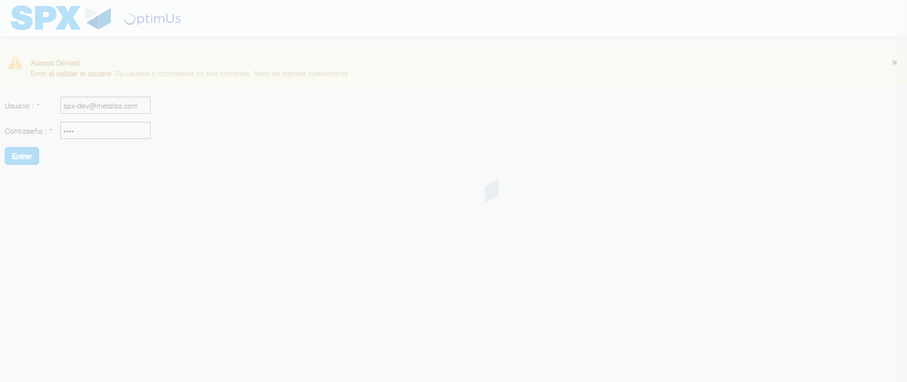Image file-name: QC_Testing-tc002_SPX_Dev5_Crear_Requisicion_Spot_Con_FAD_Tipo_Cobro_CC-1790170197812

Step 2 - Select to UEN and Access to Spot Buy Requisitions : UEN Correctly selected and Correct access
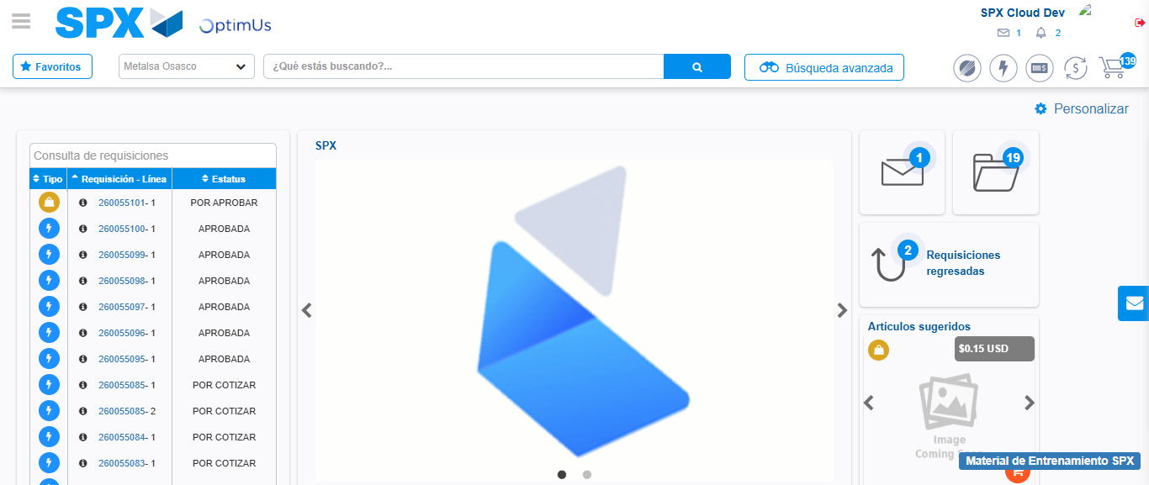Image file-name: QC_Testing-tc002_SPX_Dev5_Crear_Requisicion_Spot_Con_FAD_Tipo_Cobro_CC-1790170221993

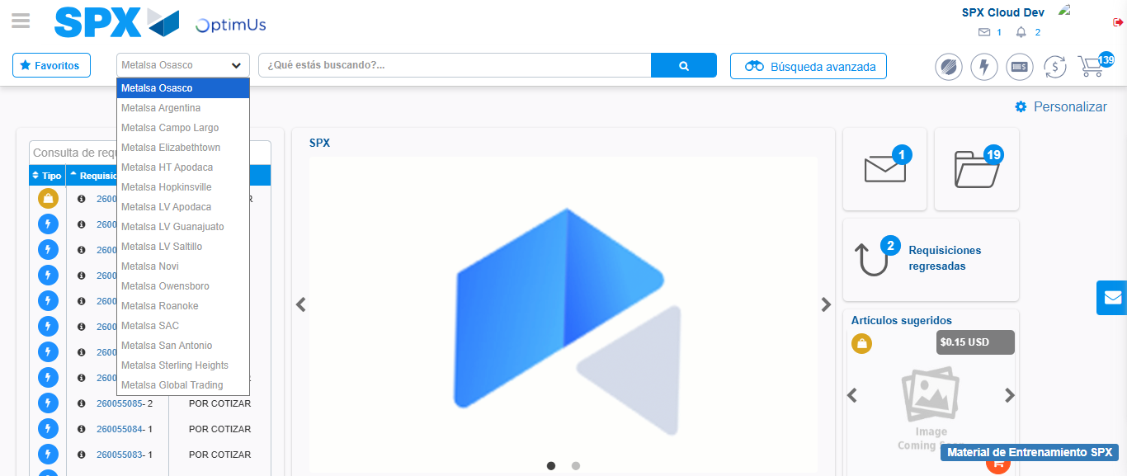Image file-name: QC_Testing-tc002_SPX_Dev5_Crear_Requisicion_Spot_Con_FAD_Tipo_Cobro_CC-1790170222648

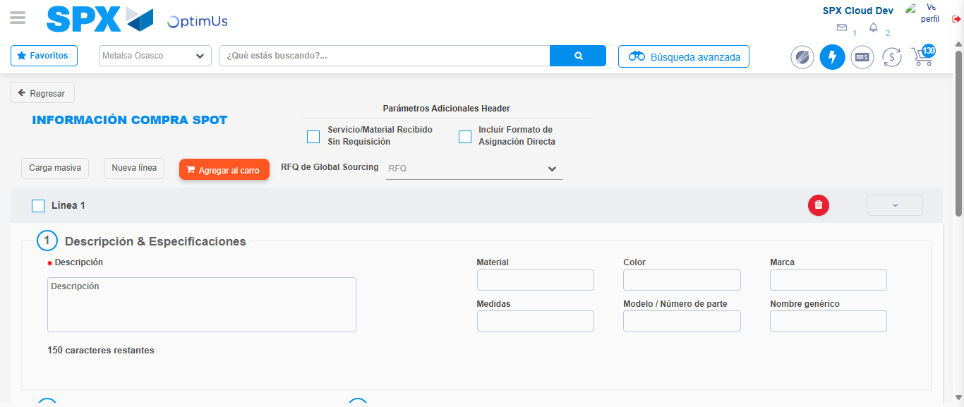Image file-name: QC_Testing-tc002_SPX_Dev5_Crear_Requisicion_Spot_Con_FAD_Tipo_Cobro_CC-1790170226881

Step 3 - Add FAD to Requisition: FAD Successfully Added
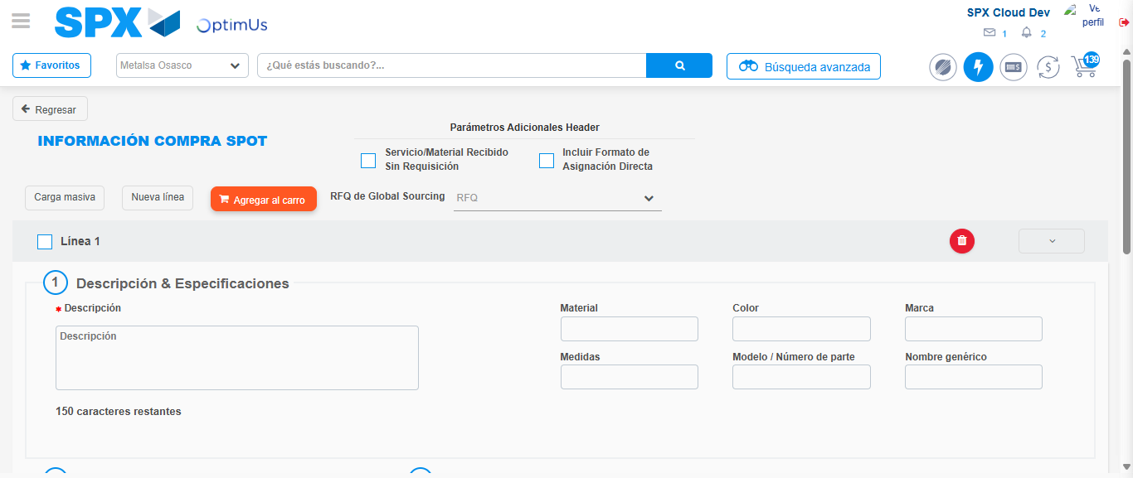Image file-name: QC_Testing-tc002_SPX_Dev5_Crear_Requisicion_Spot_Con_FAD_Tipo_Cobro_CC-1790170227241

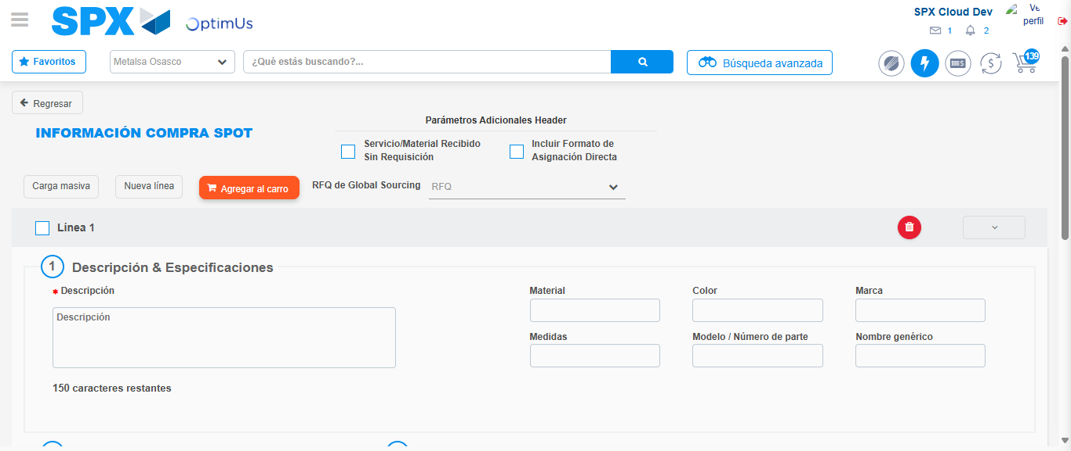Image file-name: QC_Testing-tc002_SPX_Dev5_Crear_Requisicion_Spot_Con_FAD_Tipo_Cobro_CC-1790170227503

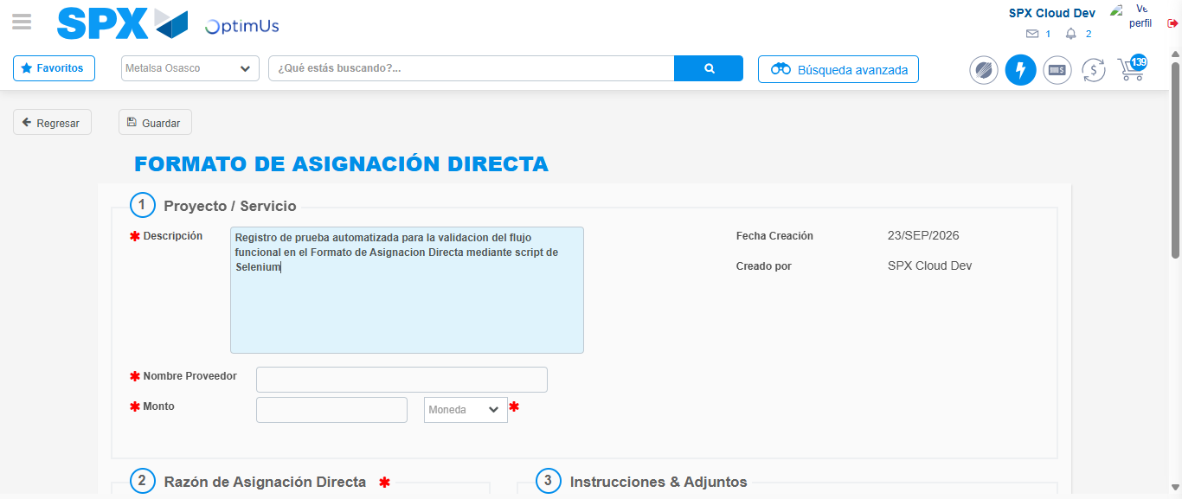Image file-name: QC_Testing-tc002_SPX_Dev5_Crear_Requisicion_Spot_Con_FAD_Tipo_Cobro_CC-1790170230360

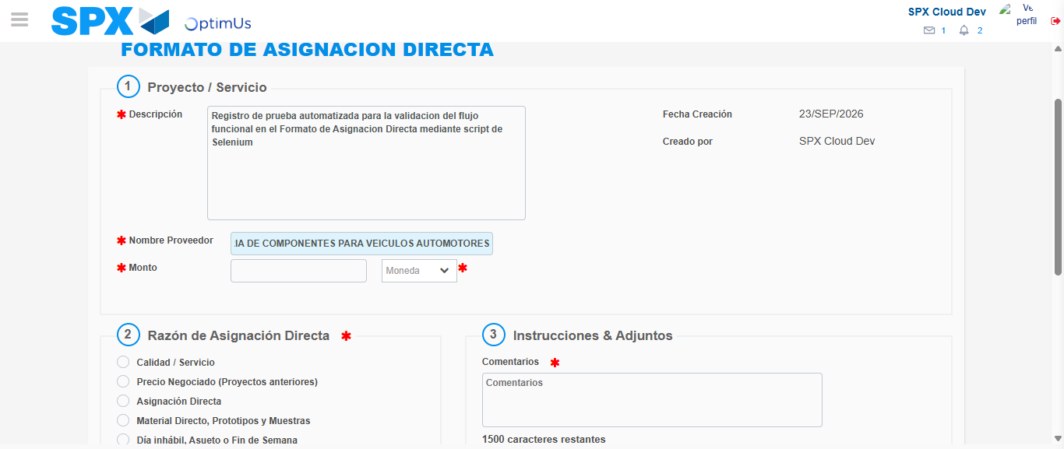Image file-name: QC_Testing-tc002_SPX_Dev5_Crear_Requisicion_Spot_Con_FAD_Tipo_Cobro_CC-1790170239683

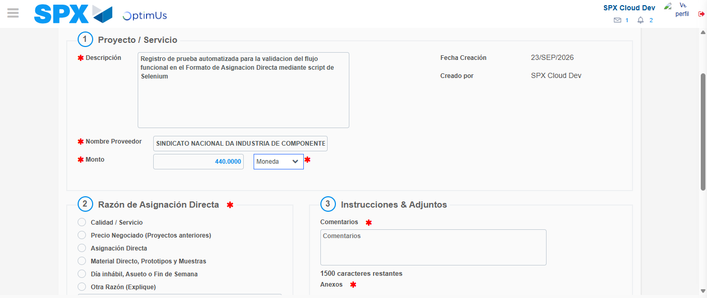Image file-name: QC_Testing-tc002_SPX_Dev5_Crear_Requisicion_Spot_Con_FAD_Tipo_Cobro_CC-1790170240131

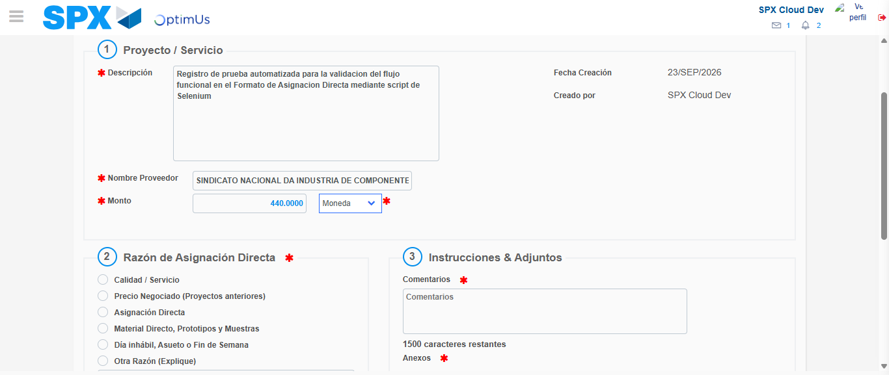Image file-name: QC_Testing-tc002_SPX_Dev5_Crear_Requisicion_Spot_Con_FAD_Tipo_Cobro_CC-1790170240350

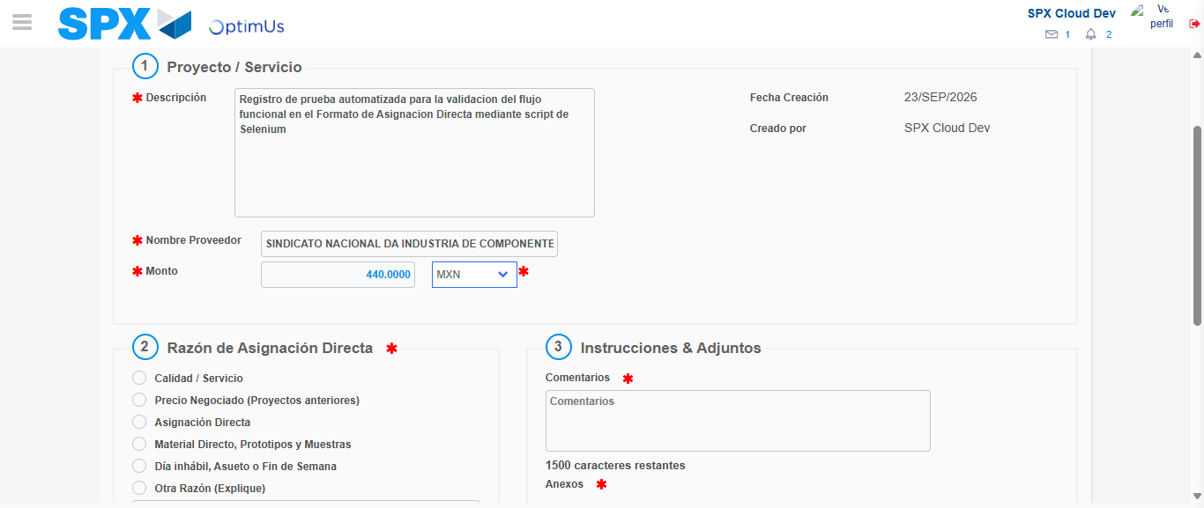Image file-name: QC_Testing-tc002_SPX_Dev5_Crear_Requisicion_Spot_Con_FAD_Tipo_Cobro_CC-1790170240749

Image file-name: QC_Testing-tc002_SPX_Dev5_Crear_Requisicion_Spot_Con_FAD_Tipo_Cobro_CC-1790170240959

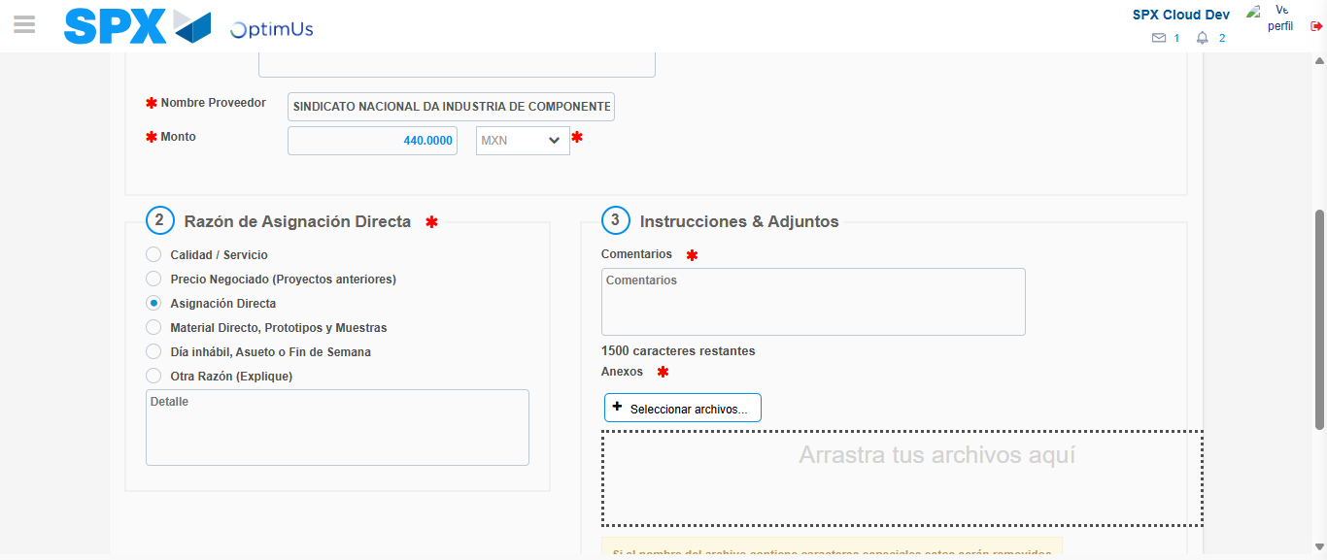Image file-name: QC_Testing-tc002_SPX_Dev5_Crear_Requisicion_Spot_Con_FAD_Tipo_Cobro_CC-1790170241814

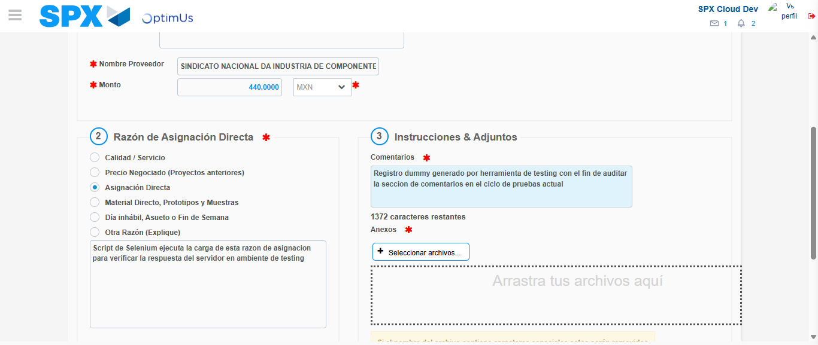Image file-name: QC_Testing-tc002_SPX_Dev5_Crear_Requisicion_Spot_Con_FAD_Tipo_Cobro_CC-1790170252952

Image file-name: QC_Testing-tc002_SPX_Dev5_Crear_Requisicion_Spot_Con_FAD_Tipo_Cobro_CC-1790170253737

Step 4 - Data Capture Spot Buy Requisition: Data captured correctly
Image file-name: QC_Testing-tc002_SPX_Dev5_Crear_Requisicion_Spot_Con_FAD_Tipo_Cobro_CC-1790170227241

Image file-name: QC_Testing-tc002_SPX_Dev5_Crear_Requisicion_Spot_Con_FAD_Tipo_Cobro_CC-1790170227503

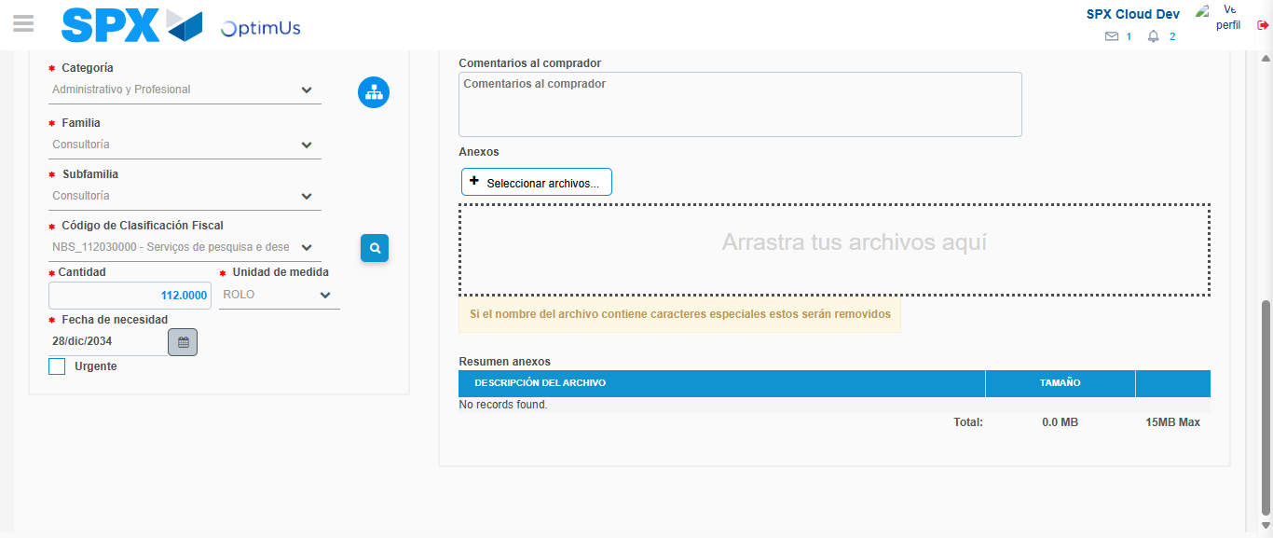Image file-name: QC_Testing-tc002_SPX_Dev5_Crear_Requisicion_Spot_Con_FAD_Tipo_Cobro_CC-1790170278983

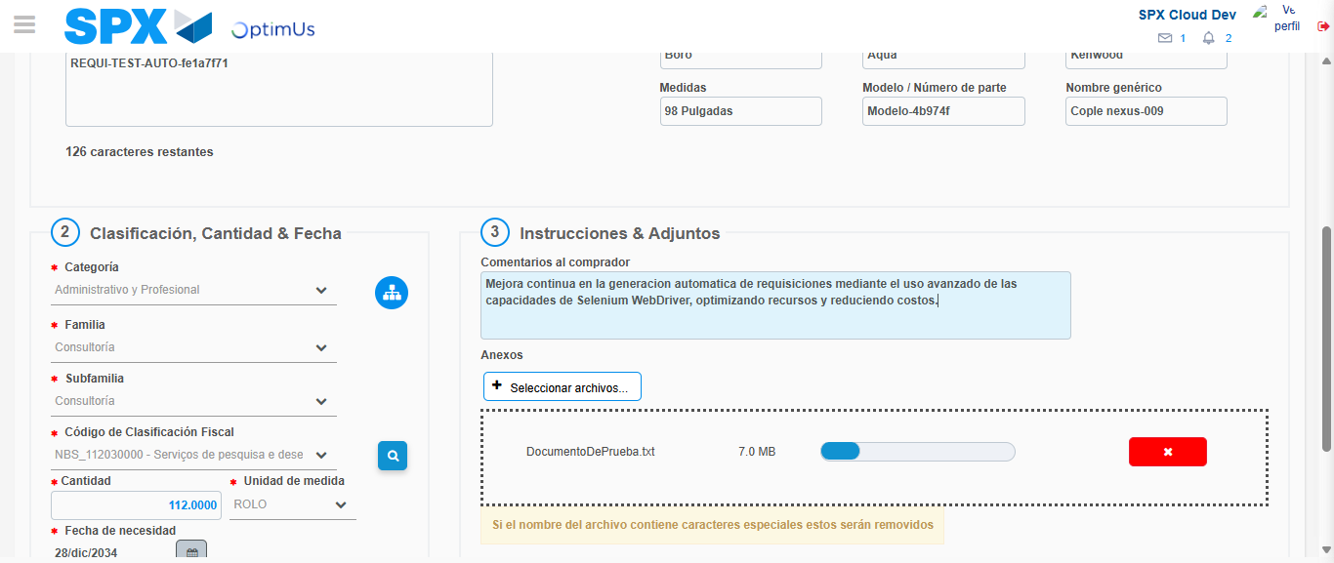Image file-name: QC_Testing-tc002_SPX_Dev5_Crear_Requisicion_Spot_Con_FAD_Tipo_Cobro_CC-1790170279849

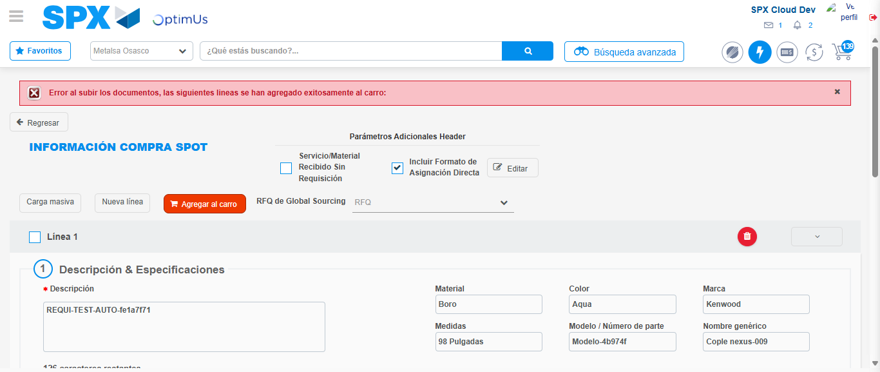Image file-name: QC_Testing-tc002_SPX_Dev5_Crear_Requisicion_Spot_Con_FAD_Tipo_Cobro_CC-1790170292170

Step 8 - Return to Main Page SPX : Return to Main Page SPX
Image file-name: QC_Testing-tc002_SPX_Dev5_Crear_Requisicion_Spot_Con_FAD_Tipo_Cobro_CC-1790170221993

Image file-name: QC_Testing-tc002_SPX_Dev5_Crear_Requisicion_Spot_Con_FAD_Tipo_Cobro_CC-1790170222648

Image file-name: QC_Testing-tc002_SPX_Dev5_Crear_Requisicion_Spot_Con_FAD_Tipo_Cobro_CC-1790170226881

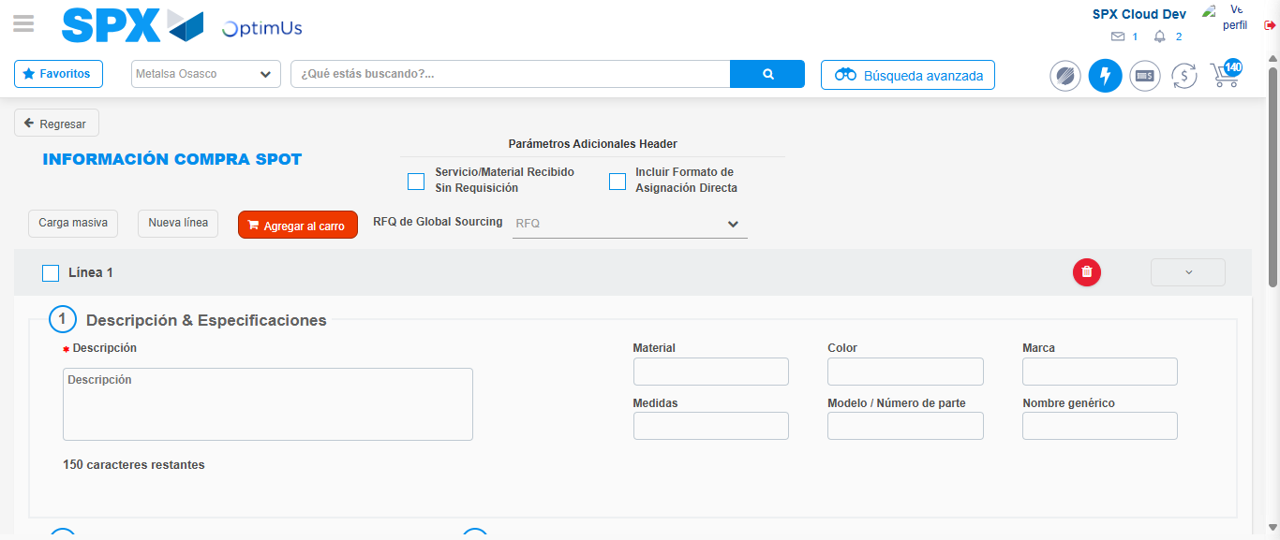Image file-name: QC_Testing-tc002_SPX_Dev5_Crear_Requisicion_Spot_Con_FAD_Tipo_Cobro_CC-1790170306601

Image file-name: QC_Testing-tc002_SPX_Dev5_Crear_Requisicion_Spot_Con_FAD_Tipo_Cobro_CC-1790170306817

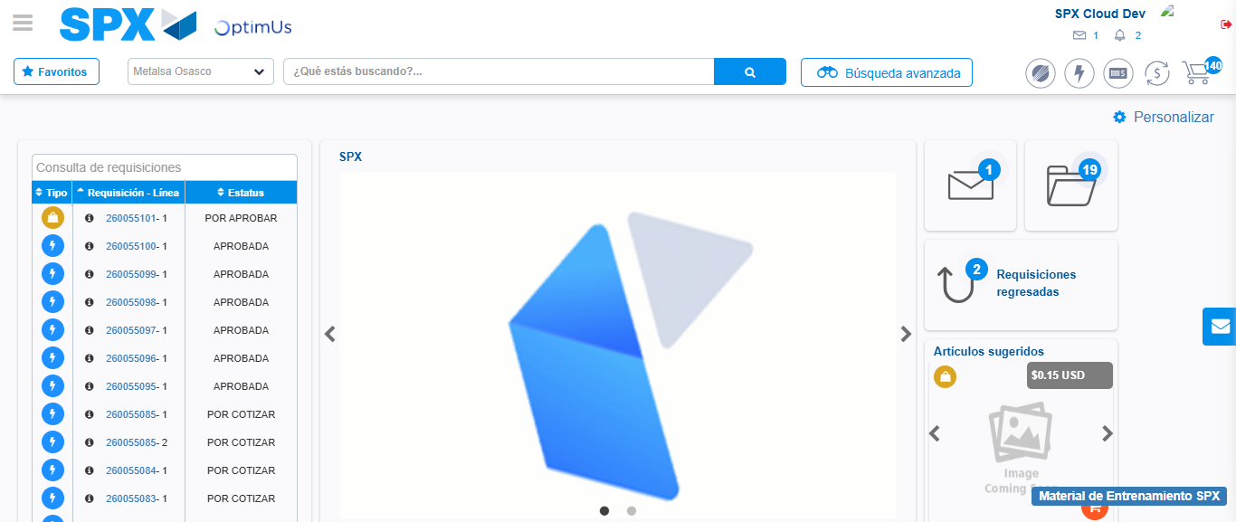Image file-name: QC_Testing-tc002_SPX_Dev5_Crear_Requisicion_Spot_Con_FAD_Tipo_Cobro_CC-1790170328020

Step 9 - Log Out : Log Out SPX
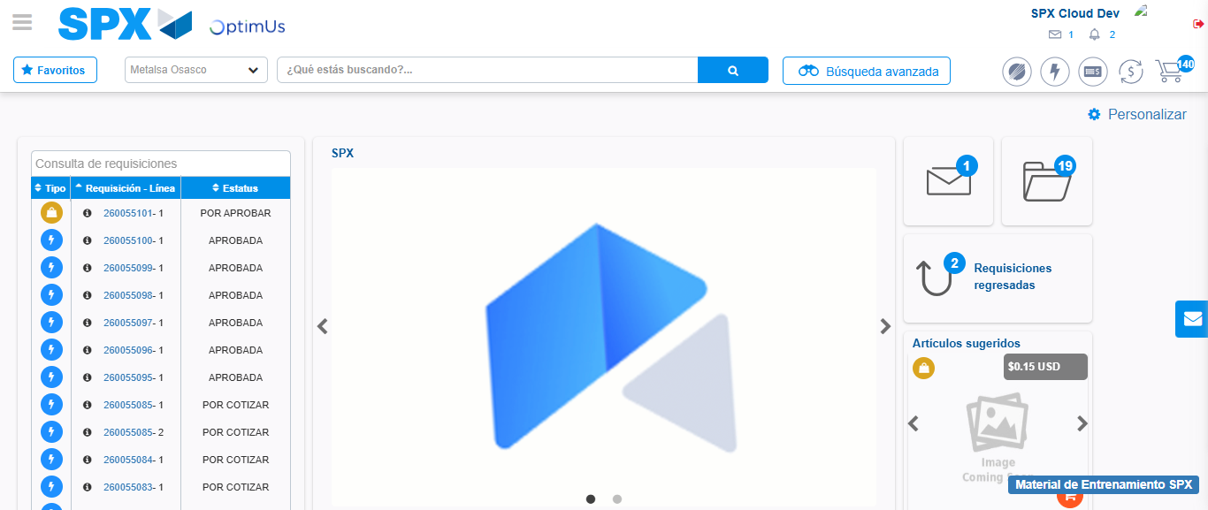Image file-name: QC_Testing-tc002_SPX_Dev5_Crear_Requisicion_Spot_Con_FAD_Tipo_Cobro_CC-1790170328369

